Dear Parents and Carers,
Welcome to Edsential, your school's new catering provider! We’re delighted to serve over 140 schools across the North West of England, offering high-quality meals with fresh ingredients prepared daily. As a Community Interest Company, we reinvest back into services for children and young people, ensuring our meals are not only delicious but also ethically sourced and sustainable.
Quality food using quality ingredients.
Every year, we serve over 3 million meals, carefully selecting ingredients to provide your children with the most sustainable, seasonal, and healthy food available.
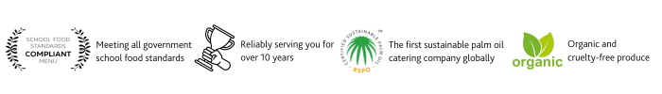
Sustainability
Edsential is proud to be the first catering company globally to use only sustainable palm oil, certified by the Roundtable on Sustainable Palm Oil. We revamped our entire supply chain to achieve this goal.
Menu selection and Theme days.
Our menus run on a three-week cycle, featuring freshly baked bread, seasonal vegetables, salad, fresh fruit, and organic yogurt daily. Each school has a bespoke menu tailored to its unique needs, and we actively involve pupils in menu choices through class participation and school groups.
Allergen and Special Diets Management
We take food allergies and special diets very seriously. Every child deserves access to a nutritious meal, regardless of dietary needs. Currently, we cater to over 900 special diets daily, including those related to allergies, religious beliefs, veganism, and medical conditions. The Department for Education mandates that schools and catering providers follow statutory guidance to support pupils with medical conditions. We also adhere to best practices and guidance from the Food Standards Agency and Local Authorities to manage allergens effectively. Successful implementation of these arrangements relies on the collaboration and commitment of parents, schools, Edsential, and our Catering Teams.
Important Allergen/Intolerance Information
Food allergies and intolerances are serious medical conditions, and we’re committed to managing them safely. To ensure we provide safe and suitable meals for your child, we require a medical letter from a recognised health professional detailing your child’s condition, name and date of birth and should be handed in to the school office. This letter can be obtained from your GP, hospital, or clinic. We do not accept private clinics’ results. Without this documentation, we may not be able to offer all menu options to your child.
Free school meals
All children in Reception, Year 1, and Year 2 are entitled to universal free school meals. If you believe your child qualifies for additional free school meals based on your circumstances, please contact the school office or visit www.gov.uk/apply-freeschool-meals.



