
The Parish of St Maximilian Kolbe Newsletter Fourth Sunday of Easter – 21st April 2024
Tel: 01928 577755
Email p.wright557@btinternet.com Website saint-maximilian-kolbe.org
Prayer Line on 07443 639416 all calls treated confidentially.
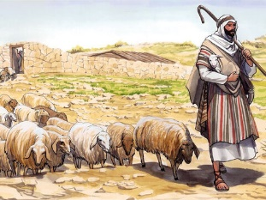
YouTube

Masses from St. Edward’s are streamed live on our YouTube page – Saint Maximilian Kolbe Parish Masses from Holy Spirit will be streamed on our Facebook Page

https://www.youtube.com/channel/UCZaCv2yYfq39wZY2phiaymg
St. Maximilian Kolbe Parish Mission 18th – 22nd May 2024

We are excited to be welcoming Deacon Keith Strohm from Chicago to lead a Parish Mission for us in May. Keith is a deacon of the Archdiocese of Chicago. He is an international speaker and has helped tens of thousands of men and women hear the Gospel message and encounter the mercy, love and power of Jesus Christ.

Deacon Keith will be preaching at Masses across the weekend followed by 3 evening meetings on the Monday, Tuesday and Wednesday to which all parishioners are invited!
This will be a Spirit filled Mission for all involved as we continue to work for Parish Renewal – please put the dates in your diary and attend as much of the Mission as possible!
INVITE FAMILY, FRIENDS, FELLOW PARISHIONERS TO THIS EXCITING TIME OF MISSION
Watch the Video of Deacon Keith’s Invitation to our Mission https://youtu.be/SJZ0LcvSzSU
There’s also an Interview with Fr. James Mallon and Deacon Keith https://www.youtube.com/watch?v=niImAua1Qf0

Please pick up posters and fliers from Church to advertise the Mission
Remember, personal recommendation and personal invitation have the greatest impact!
St. Vincent de Paul Society

At the end of each mass, next weekend, - Saturday 27th April and Sunday 28th April –
Kate Birkenhead, Membership Support Officer for St Vincent de Paul (Shrewsbury Diocese), will be leading on a short address outlining the role of the St Vincent de Paul Society and asking for volunteers to revitalise the St Vincent de Paul local group, with her support. She will be available at the end of each mass to answer any of your questions.
Warm Space
Our Warm Space initiative continues each with tea, coffee, and toast Tuesdays
from 9.30 – 11.30 am at St. Edward’s.
Thank you to those who have volunteered – more are always needed!
Please sign up on the sheets in our church buildings. All Are Welcome!
Please keep the following in your Prayers!
Jacqui Dunn, Patrick Brolly, Catherine Harrison, Pauline Hanlon,
Barbara Burgess, Maureen Pattinson, Darren Brown, Mrs Christina Stone,
Neil Watling, Maureen, Sheila Jones, Lillian Redican

If you would like to add a person’s name to the prayer list, please pass it into one of the sacristies.

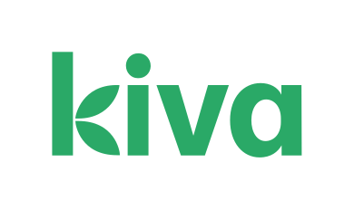
CAFOD Donations

We have recently received a letter of thanks from CAFOD for a donation of £13.71.
This donation followed a collection for the Turkey-Syria Earthquake Appeal, and has helped to provide vital medical help, shelter, food clean water, as well as winter kits to help people cope with freezing temperatures. Many thanks for your generous support.
CHRIST IS RISEN!
HE IS RISEN INDEED!
ALLELUIA!
Thanks to all who have worked so hard to ensure that our buildings and people are ready for the great celebration of Eastertide.
We fast and prepare for forty days; we celebrate the Good News of the Resurrection for fifty days!
Many thanks for your gifts to me as we celebrate Easter together.
Google – One Hope Project MASS OF UNITY
They are a Catholic Worship Group, their Mass setting and video are truly uplifting
Ladies Group – Wednesday 24th April at 7:30pm

Talk about Refugee Support – All are Welcome
Raffle: Carol
Runcorn Food Bank
The foodbank are currently requesting donations of:

Toilet Rolls, Tinned Spaghetti, Tinned Meat, Tinned Fish, Tinned Fruit, Tinned Tomatoes, Coffee, Fruit Juice, Household Cleaning Products, Shower Gel, Shampoo, Deodorant

9.8kg of food and toiletries have been delivered to the Foodbank warehouse in the last week. Many thanks to all parishioners for their contributions.

Please consider supporting the Foodbank financially as an alternative to giving food, as it costs over £18,000 per year to run the foodbank.

Kiva

Our Kiva account continues to help support businesses around the world with micro-loans.
Loans have been sent recently to the following causes:

- Bibilola, a farmer in Tajikistan, to help pay for her child’s medical costs
- Abduaziz, also from Tajikistan, to help pay for his university tuition
- Monther, who lives in Palestine, to help pay for surgery costs.

Thank you to Alice for managing the account and selecting the loan recipients.
Adult Formation

We continue to meet Monday evenings at 7.00pm.
Throughout Eastertide we’ll be reading the Acts of the Apostles. Acts inspire us, telling the story of the newborn Church, our story too!
Join us for a refreshing and inspiring hour of “BREAKING OPEN THE WORD OF GOD”!
This would be a wonderful way to enable you to be more joyful throughout Eastertide and help you grow as a Missionary Disciple?

