

The Parish of St Maximilian Kolbe Newsletter 15th Sunday in Ordinary Time – 12th July 2026
Tel: 01928 577755
Email p.wright557@btinternet.com Website saint-maximilian-kolbe.org
Prayer Requests – please pass these into the Sacristy.
YouTube
Masses from St. Edward’s are streamed live on our YouTube page – Saint Maximilian Kolbe Parish. Masses from Holy Spirit will be streamed on our Facebook Page

https://www.youtube.com/channel/UCZaCv2yYfq39wZY2phiaymg
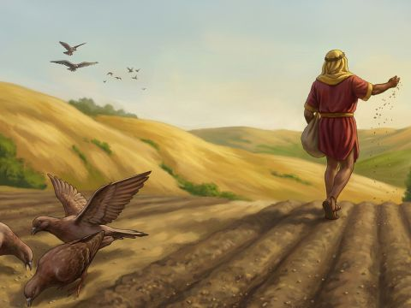

Please keep the following in your Prayers!
Claire Kennedy, Carol Davison, Jacqui Dunn, Patrick Brolly, Catherine Harrison,
Pauline Hanlon, Barbara Burgess, Darren Brown, Neil Watling, Sheila Jones, Julius,
Maz Thompson, Tom McKenzie, Anne, Fred Scowcroft, Michelle Hughes, June Keane, Lucas Goodier, Laura Kelly, Marilyn & Dave, Riley Hesketh

If you would like to add a person’s name to the prayer list, please pass it into one of the sacristies.

Warm Space – Tuesdays 9.30 – 11.30 am St Edward’s

All Are Welcome for tea, toast and a chat!

THE FEAST OF ST JAMES the APOSTLE

We will anticipate the Feast by celebrating on Friday 24th July, Mass will be at 10.00am in St Edward’s
The Tapas Evening will start at 6.30 pm, please bring you own preferred drink
The cost for the evening is £7.50 - Please sign up on the sheets at the back of each church by Sunday 19th July

Knit and Natter – Monday 13th July 1:30 – 3:30pm

If you can’t knit, come for a natter. All are welcome.

Second Collection for Sea Sunday

There will be retiring collections at Masses this weekend, 11th / 12th July to support ‘Stella Maris’.

Stella Maris helps thousands of seafarers every year who are struggling with loneliness, exhaustion, bullying and exploitation. Thank you for your generous support.
CAFOD-DEC Venezuela Earthquake Appeal

As part of the UK Disasters Committee, CAFOD has launched its Venezuela Earthquake Appeal

You can help our neighbours affected by the 24 June earthquakes in Venezuela with emergency shelter, water and food. CAFOD is already working with local Church partners to support people who have lost their homes, but we need your support to help more survivors. Your donation will provide essential supplies and help families rebuild their lives.

Donate to the CAFOD-DEC Venezuela Earthquake Appeal today: cafod.org.uk/Venezuela or call 0300 999 0030. There will also be a basket available for donations in our churches for the remainder of July. Please keep our neighbours in Venezuela in your prayers.

Birthday Celebration – Sunday 19th July
After the 10.30 am Mass next Sunday Clare will be bringing cake to celebrate her birthday with her Church Family! All are welcome to stay for a slice!
Rhoscolyn 2026

For those joining us for our weekend in Rhoscolyn please can you pay the balance by
Sunday 4th October.

SVP Runcorn Conference
There is an interest in both Runcorn parishes to restart an SVP conference to tackle need in our communities.
A meeting will be held at Our Lady, Mother of the Saviour Church on Thursday 16 July at 6.30p.m.
Please share this invitation with family and friends, and all who want to support people in their community.
All are welcome. Contact Janet Lawrence on 07927426391 or 01928 573625 if you need more information.

Lourdes 2026
Clare, Josie and Gracie will be travelling to Lourdes in July with the Diocesan Pilgrimage, including 72 Young People! If you would like them to take any intentions to the Grotto, please pass these to them by Sunday 26th July. Please don’t put any money in the envelopes with the intentions as they are burnt. If you wish to make any donations or have any candle lit, please use a separate envelope and mark envelopes accordingly. Thank you.
Be assured, the Parish will be kept in prayer during their time in Lourdes!

Confirmation Preparation 2026
Those in Year 8 and above (from September 2026) are invited to prepare to receive the Sacrament of Confirmation beginning on Sunday 6th September after the 10.30 am Mass at St Edward’s. A full list of the weekly meetings will be available soon. This year we will be using the New Alpha Youth Series, so please speak to Clare or Fr Peter if you wish to be confirmed.

Volunteers Required!
In order to help prepare our young people, volunteers are needed. It would be great if those confirmed last time would come along to support our Confirmands. Please let Clare or Fr Peter know if you can help, full training will be available and DBS checks will be carried out.

Faith in Action

Faith in Action is for young parishioners in Year 5 and above.

For those who have already confirmed that they are attending, our next meeting is this weekend
Sunday 12th July after the 10:30am Mass.
This will be our trip out when we will be going adventure golfing at Cheshire Oaks!
We will have something to eat before we leave. Parents are asked for donations of £10 towards the cost, which should be placed in an envelope marked with the young person’s name.

Runcorn and District Food Bank
The foodbank is currently requesting donations of:
Teabags, Coffee, Pasta Sauce, Tinned Soup, Tinned Spaghetti,
Men’s Deodorant, Shampoo, Bags for Life
The foodbank also relies on financial donations, as well as gifts of groceries.

Runcorn and District Foodbank could not operate without food donations such as yours and all donations are welcome – both financial and goods.

