Year 2 DISCERN Autumn 1
The Chosen People
- Express a point of view about the importance of…
- Ask and respond to questions about the experiences and feelings of…
- Share a personal response to an appropriate image/painting(s) of …giving reasons for their preference.
- Listen to the stories and experiences of others from different communities and parts of the world about how they celebrate…
- Imagine how…
What could happen if people chose not to look after God’s world?
How do you think Abraham felt when he had to leave his homeland?
Do you think Sarah was right to go with her husband when he asked her to (what things would she need to consider before making her choice)?
How do other faiths view Abraham and his relationship with God?
Was it easy for Abraham to trust God (what difficulties did he face)?
Do you think God had forgotten about the Israelites?
Look at these three pictures, which one to you think tells the story of Moses the most clearly? Are they enough to tell the story of Moses? What do you think the artist is trying to say with each picture?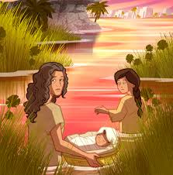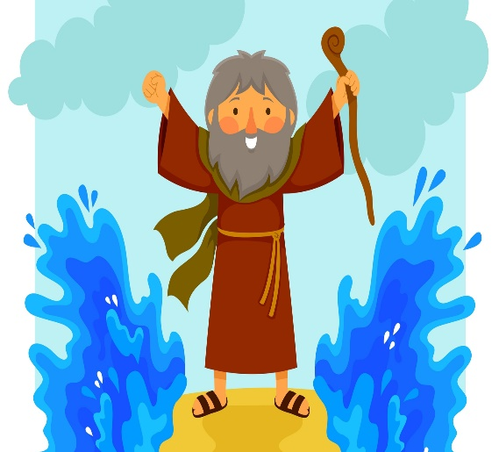

In the story of Daniel, there are three main themes: bravery, faith and being chosen. Rank these in order of importance and discuss with your partner why you have ordered them in this way.
Imagine how Daniel felt being put in the lion’s den.
Do you think Daniel was treated fairly by the king? Why / Why not?
Imagine how Daniel felt after God had saved him. What do you think he did next?

Which of the three people we have been learning about (Abraham, Moses and Daniel) do you think showed the most faith in God?

Year 2 DISCERN Autumn 2
The Mystery of God
- Express a point of view about the importance of…
- Ask and respond to questions about the experiences and feelings of…
- Share a personal response to an appropriate image/painting(s) of …giving reasons for their preference.
- Listen to the stories and experiences of others from different communities and parts of the world about how they celebrate…
- Imagine how…
What do you think Heaven is like? Does everyone have the same view? Why/why not?
Do you think everyone should be allowed to go to Heaven?
Look at the images below. Which image do you think shows the Trinity the most clearly? Why? Is it possible to explain the Trinity in a picture?
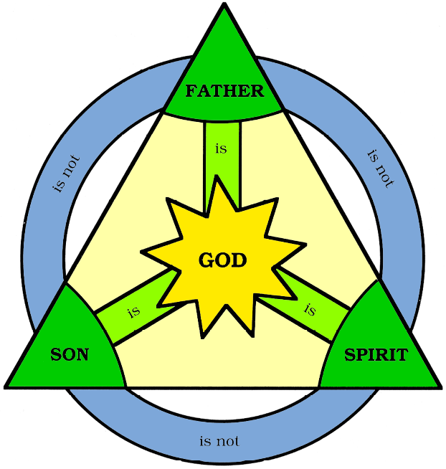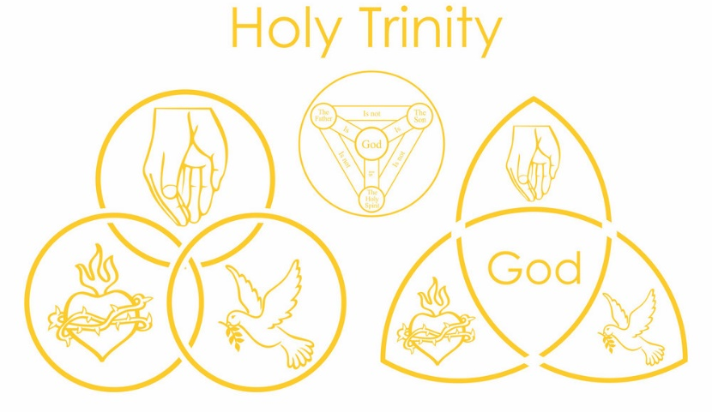
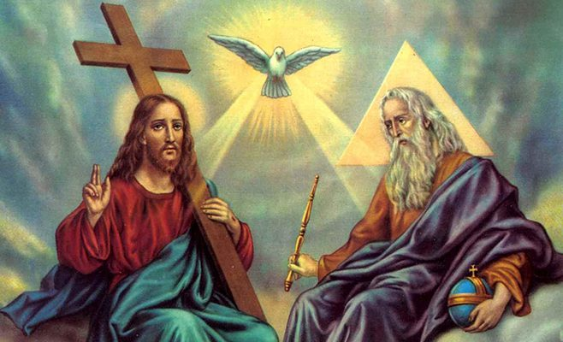
How do you think Mary felt when the angel spoke to her?
What would happened if Mary had said no?
Look at a selection of Christmas cards (some religious and some not). Sort the cards into a diamond nine as to which one tells the Christmas story the most accurately.
Imagine you were Joseph, how would you have reacted when you found out Mary was having God’s son?
Compare traditional and modern pictures of the Annunciation. Which do you prefer and why? Which one shows the Bible story the most clearly? What was the artist trying to say with the picture they created? Does it faithfully represent the Bible story?
Look at a selection of Christmas preparations: Advent calendars, Christmas cards, angel, Santa Claus, elf on the shelf, crib, decorations, presents, trees, carols etc. Which are the most important preparations for Christmas (which preparations could families leave out and still faithfully celebrate Christmas)?
How do you think the shepherds were feeling after the angels appeared?
Do you think the shepherds knew that Jesus was truly God? Why?
Do you think the shepherds and the wise men were the best visitors for baby Jesus? Why / Why not?
Should both poor and rich people be chosen to visit Jesus? Why?

