Year 6 Autumn 1 – The Kingdom of God
- Should everyone be invited to the Kingdom of God? Is it for everyone? Is it too hard? Are there too many sacrifices? What does Jesus say about it? What evidence does Jesus give about who the Kingdom of God is for? (use parables to support your answers)
- Rank the values of the Kingdom of God. Justify your choices. (they are all equal from God)
- What matters more, going to Heaven or having justice on earth?
- Should everyone be invited to the Kingdom of God? Why/Why not? Give reasons for different opinions.
- There is much to learn from the parable of the Rich Man and Lazarus. Agree or disagree?
- What would happen if no one told anyone else about the Kingdom of God?
- St Therese of Lisieux is the best way to live the values of the Kingdom. Do you agree? (We don’t all have the same route on that path)
- You should use your gifts to share the Good News of Jesus. Agree or disagree?
- Having a relationship with Jesus transforms your life. Agree or disagree?
- Consider the view that you should use your gifts with others.

Year 6 Autumn 2 – Justice
- What if there were no rules in school.
(Newspaper Report – report on what school would be like / what would happen at lunchtime / during PE / on the playground)
- Give children any story and ask them if the person in the story is acting fairly.
Follow this by exploring - What do we mean by justice? What is your understanding of being fair? What is a Christian understanding of Justice?
- All stand up in class and give an example when they think something wasn’t fair – can the others all discern whether it was an unjust act or not?
- “Everyone has the right to a standard of living which is adequate for the health and well being of him/herself and family, including food, clothing, housing, medical care and necessary social services… Everyone has the right to education.” UN Declaration of Human Rights.
Do you agree or disagree? Why is it important?
- Is it our responsibility to help refugees and why? Can you find evidence in the Bible to support your point of view?
- Who is the better disciple: Oscar Romero or Martin Luther King?
- Whose responsibility is it to tackle injustice?
- Why do you think Elizabeth referred to Mary as the Mother of my Lord?
- Should we prepare to celebrate the birth of Jesus?
- Is there a right way to prepare for Christmas?
- I think spending time with your family is the most important thing to do at Christmas.
I think going to church is the most important things to do at Christmas.
Would you agree with either of those? Why?
- 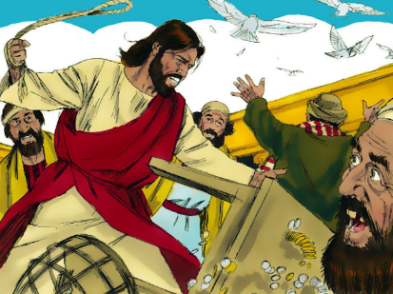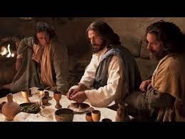
Which picture best represents Jesus? Why?
Do you think Jesus is more God or human?
Are these fair representations of Jesus? Would everyone agree?

